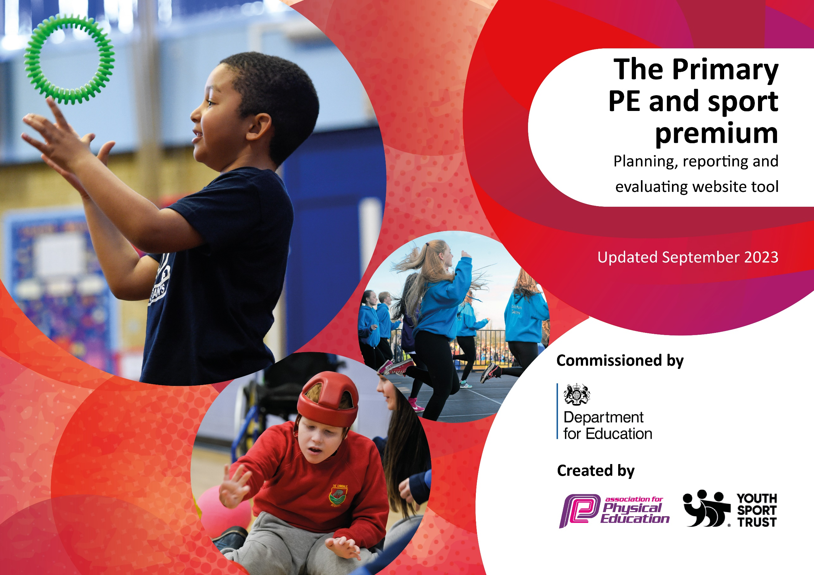

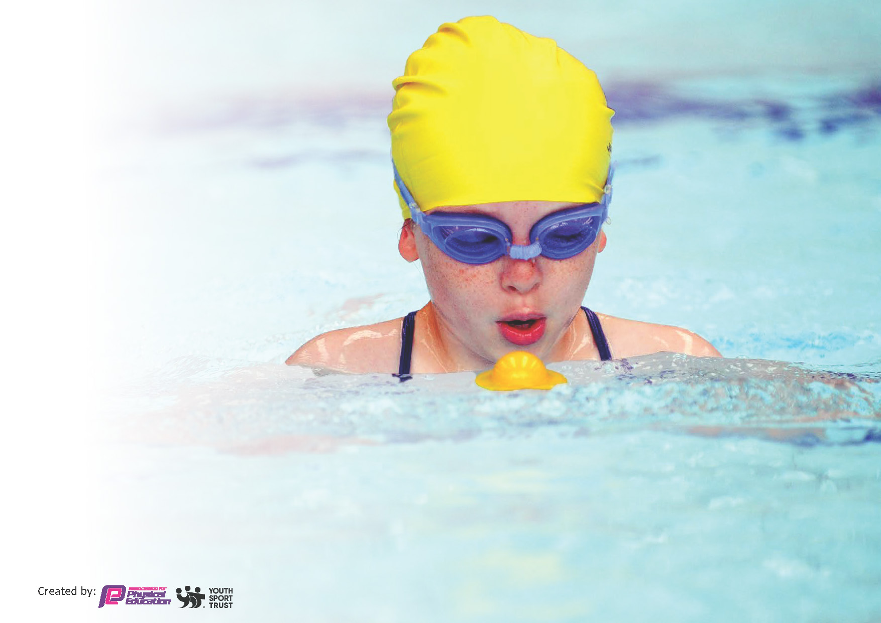
This template can be used for multiple purposes:
by:
- It enables schools to effectively plan their use of the Primary PE and sport premium
- It helps schools to meet the requirements (as set out in guidance) to publish information on their Primary PE and sport premium
- It will be an effective document to support Ofsted inspections enabling schools to evidence progress in Physical Education (PE) and evidence swimming attainment, which forms part of the PE National Curriculum. We would recommend schools consider
the Intent, Implementation and Impact of any spend, as examined within the Education Inspection Framework.

It is important that your grant is used effectively and based on school need.

Schools must use the funding to make additional and sustainable
improvements to the quality of the PE, School Sport and Physical Activity (PESSPA)
they offer. This means that you should use the Primary PE and sport premium to:

- Build capacity and capability within the school to ensure that improvements made now will benefit pupils joining the school in future years
- Develop or add to the PESSPA activities that your school already offers.

The Primary PE and sport premium should not be used to fund capital spend projects; the school’s core budget should fund these. Further detail on capital expenditure can be found in the updated Primary PE and sport premium guidance.

The Primary PE and sport premium guidance, outlines 5 key priorities that funding should be used towards. It is not

necessary that spending has to meet all the key priorities, you should select the priorities that you aim to use any funding towards.

Although completing this template is not a requirement for schools, schools are required to publish details of how they spend this funding. Schools must also outline what the impact this funding has had on pupils’ PE and sport participation and attainment and how any spending will be sustainable in the future. All funding must be spent by 31st July 2025.

The Department for Education has worked closely with the Association for Physical Education (afPE) and the Youth Sport Trust (YST) to develop this template and encourages schools to use it. This template is an effective way of meeting the reporting requirements of the Primary PE and sport premium.
Review of last year’s spend and key achievements (2023/2024)

We recommend you start by reflecting on the impact of current provision and reviewing your previous spend.

Activity/Action | Impact | Comments
Beginning to implement new teaching and assessment PE scheme (Get Set 4PE).  Development and purchase of new resources for scheme of learning and providing range of equipment for children to access at lunch and break times.  Addition of new sporting activities to the NOS sporting calendar to engage and provide broader range of sports being accessed for children.  Use of specialist coach for ‘fun fit’ sessions with SEND children. Sports coach providing different activities for children to partake in during lunchtimes.  Continued use of participation tracker to identify children and participation in after school clubs and outside of school activities.  Water Sports day and networking with new contacts to promote broader balance of sports throughout school year.  Increase in pupil and activity levels through implementation of daily mile scheme within school timetable throughout the year.  Promoting schools sporting achievements to a wider audience | Curriculum development with specific sports identified. Awareness of trends and clear curriculum plan in place. All classes using Get Set 4 PE with timetables in place.  Greater amount of children engaged at lunchtimes using new equipment.  Positive interactions towards new equipment from children.  Year 6 Sports Leads initiated and now assisting with use and care of new equipment.  Contact with Rushcliffe School Games lead to assist with school trips and suggestions about how to promote new sports within school.  Children have positive relationships with sports coach. Positive impact on social and emotional behavior for targeted pupils.  Achievements from children being celebrated during assemblies. Displays in school showcasing successes in sports.  Embedding range of contacts to ensure ongoing range of sports being accessed across year groups.  Children remained engaged in daily mile targets throughout year. Celebrated success within weekly assemblies. New awards and visuals to display distance covered throughout the year. Positive attitude to running the mile present throughout school.  Use of Dance Lobo in Spring term helped to engage positive attitude of girls within the school. Performed in front of larger audience at end of unit. Cricket day from Notts CCC – Chance to Shine Water Sports Day at National Water Sports Centre | Still embedding scheme of learning and ensuring teachers and sports coaches comfortable teaching from planning.

Key priorities and Planning

Action – what are you planning to do | Who does this action impact? | Key indicator to meet | Impacts and how sustainability will be achieved? | Cost linked to the action
Maintain Get Set 4 PE scheme of learning to assist with delivery of P.E across all year groups and embed within Normanton P.E curriculum. | coaches - as they need to lead the activity  all pupils – as they will take part. | 1. Increase confidence, knowledge and skills of all staff in teaching PE and sport  2. Increase engagement of all pupils in regular physical activity and sport  3. The profile of PE and sport is raised across the school as a tool for whole school  improvement  4. Broader and more equal experience of a range of sports and physical activities offered to all pupils  5. Increased participation in competitive sport. | Staff becoming trained and able to follow units of work confidently. P.E coach to be able to follow and adapt lesson plans and assist with planning/assessment data confidently. | £1755 costs for subscription of Get Set 4 PE service over 3 year cycle.
Invest money into purchasing new lunchtime equipment and PE lessons for EYFS, KS1 and KS2 to encourage engagement of all children in physical activity. | PE lead to purchase equipment  Lunchtime staff and all staff on playground duty to use equipment  Children who will use the equipment | 1. Increase confidence, knowledge and skills of all staff in teaching PE and sport  2. Increase engagement of all pupils in regular physical activity and sport  3. The profile of PE and sport is raised across the school as a tool for whole school  improvement  4. Broader and more equal experience of a range of sports and physical activities offered to all pupils  5. Increased participation in competitive sport. | Up to date equipment provided to children on rota during week  Greater engagement from children on the playground during lunch and break times | £588.55 cost of expenditure on Balance Bike Lessons, Yoga Mats and general equipment including footballs and goal nets.
Celebrate sporting achievements in weekly whole school assemblies.  Ensure PE board is up to  date and visible to raise profile.  Arrange assemblies/activity days led by sports personalities/athletes so  pupils can identify with success and aspire to achieve | Children who do sport outside of school celebrated to inspire others  PE lead | 1. Increase confidence, knowledge and skills of all staff in teaching PE and sport  2. Increase engagement of all pupils in regular physical activity and sport  3. The profile of PE and sport is raised across the school as a tool for whole school  improvement  4. Broader and more equal experience of a range of sports and physical activities offered to all pupils  5. Increased participation in competitive sport. | Children showcased in assemblies when completing sporting achievements.  Use of ‘Sports Star’ from P.E coach with weekly award.  Competitions taken part in with Equals Trust – Boccia etc.  Inter-house competitions led by teachers/sports coaches – Sports Day.
Enter inter-school competition and festivals where possible to provide  opportunities for pupils  to represent the school and take part in a broad range of sports and activities.  External PE providers to offer a broad range of sports in PE lessons and extra-curricular clubs  Companies/individuals coming to school for particular sport provision/focus days to expose all pupils to sports. | P.E lead and Sports Coach | 1. Increase confidence, knowledge and skills of all staff in teaching PE and sport  2. Increase engagement of all pupils in regular physical activity and sport  3. The profile of PE and sport is raised across the school as a tool for whole school  improvement  4. Broader and more equal experience of a range of sports and physical activities offered to all pupils  5. Increased participation in competitive sport. | Meetings with Rushcliffe school games organizer to identify specific calendar for NOS to partake in sporting competitions.  Activity days for NOS to partake in – Beaumanor outdoor activities  Children taking part in OAA activities through specialist Forest School sessions throughout the year.  Investment in new sports for next calendar year including Pickleball. | £320 – Outdoor Persuits - Beaumanor  Purchase of new equipment for sporting activities in 24/25 – Including Pickleball - £1097

Continue integration of Get Set 4 PE scheme of learning to ensure higher quality of lessons and progression  and give greater confidence to staff when teaching PE. | P.E lead, teachers and Sports Coach | 1. Increase confidence, knowledge and skills of all staff in teaching PE and sport  2. Increase engagement of all pupils in regular physical activity and sport  3. The profile of PE and sport is raised across the school as a tool for whole school  improvement  4. Broader and more equal experience of a range of sports and physical activities offered to all pupils  5. Increased participation in competitive sport. | Primary teachers more confident to deliver effective PE with support from PE coach.  Working with P.E coach to develop understanding as to how to effectively teach, assess and delivery highly effective lessons. | Clements Coaching – £9080

Key achievements 2024-2025
This template will be completed at the end of the academic year and will showcase the key achievements schools have made with their Primary PE and sport premium spending.

Activity/Action | Impact | Comments
Effectively embedding new teaching and assessment PE scheme (Get Set 4 PE).  Development of new resources for scheme of learning and providing range of equipment for children to access throughout the year.  Addition of new sporting activities to the NOS sporting calendar to engage and provide broader range of sports being accessed for children.  Increase in pupil and activity levels through implementation of celebration awards during weekly assemblies and sports board displays.  Promoting schools sporting achievements to a wider audience | New scheme carefully planned and resources bought to provide need carefully planned implementation of sports during school year.  Teachers and coaches using new scheme and and targeting specific skills. Being taught to match whole school approach to other curriculum subject areas.  Purchase of new equipment based on scheme of work and need to children to access/use new resources.  Greater amount of children engaged at lunchtimes using new equipment.  Children have positive relationships with sports coach. Positive impact on social and emotional behavior for targeted pupils.  C  Celebrated success within weekly assemblies for ‘Sports Star awards’. New awards and visuals to display distance covered throughout the year.  Positive attitude to running the mile present throughout school.  Becoming embedded into Equals Trust schools competitions whilst engaging with Rushcliffe sports trust to maintain opportunities to access competitions for targeted children. | Pupils are benefitting from new scheme and implementation.  Staff and coaches aware of how to deliver scheme effectively and how to be users of the scheme.  Clear vocabulary and knowledge organisers/guides to improve continuity and retention next year.  Positive interactions towards new equipment from children. Use of new monkey bar frame popular during lunchtimes and breaktimes.  Continued use of participation tracker to identify children and participation in after school clubs and outside of school activities.  Greater engagement from children in PE sessions.  Ensure new sports are targeted during interventions and also new sports clubs being introduced in September through purchase of new equipment.  All girls participating and showing greater positive attitude within P.E lessons. Becoming lead roles in performances involving sports.  Focus on yearly structure for activity days which could include wellbeing. Continue to research with external suppliers.

Swimming Data
Meeting National Curriculum requirements for swimming and water safety.
Priority should always be given to ensuring that pupils can perform safe self-rescue even if they do not fully meet the first two requirements of the National Curriculum programme of study

Question | Stats: | Further context  Relative to local challenges
What percentage of your current Year 6 cohort can swim competently, confidently and proficiently over a distance of at least 25 metres? | 7/8 children  87.5% | Use this text box to give further context behind the percentage.  e.g., 30% - we are struggling to get pool space due to our local pool closing so we have had to use a much smaller local school pool. We have had to limit the number of pupils attending swimming lessons during one term which means some pupils have attended fewer swimming lessons than others.
What percentage of your current Year 6 cohort can use a range of strokes effectively [for example, front crawl, backstroke, and breaststroke]? | 7/8 children  87.5% | Use this text box to give further context behind the percentage.  e.g., Even though your pupils may swim in another year please report on their attainment on leaving primary school at the end of the summer term 2024

What percentage of your current Year 6 cohort are able to perform safe self-rescue in different water-based situations? | 7/8 children  87.5% | Use this text box to give further context behind the percentage.
If your schools swimming data is below national expectation, you can choose to use the Primary PE and sport premium to provide additional top-up sessions for those pupils that did not meet National Curriculum  requirements after the completion of core lessons. Have you done this? | N/A
Have you provided CPD to improve the knowledge and confidence of staff to be able to teach swimming and water safety? | Yes

Signed off by:

Head Teacher: | Sarah Philpott
Subject Leader or the individual responsible for the Primary PE and sport premium: | Thomas Fisher
Governor:
Date: | 23.07.25

